**17 Introduction to the Multitenant Architecture**

**About the Multitenant Architecture**

The multitenant architecture enables an Oracle database to function as a multitenant container database (CDB).

A [CDB](http://docs.oracle.com/database/121/CNCPT/glossary.htm" \l "GUID-135FF536-DE9B-40CF-9F42-C246762BD77F) includes zero, one, or many customer-created pluggable databases (PDBs). A [PDB](http://docs.oracle.com/database/121/CNCPT/glossary.htm" \l "GUID-D6932E25-775E-4FF1-BB08-F8999629093C) is a portable collection of schemas, schema objects, and nonschema objects that appears to an Oracle Net client as a [non-CDB](http://docs.oracle.com/database/121/CNCPT/glossary.htm" \l "GUID-B2710CAA-8F00-40B3-97AB-4521D2147EE8). All Oracle databases before Oracle Database 12c were non-CDBs.

The following figure shows a CDB with four containers: the root, seed, and two PDBs. Each PDB has its own dedicated application. A different PDB administrator manages each PDB. A [common user](http://docs.oracle.com/database/121/CNCPT/glossary.htm" \l "GUID-879D936A-45FE-4E4D-8099-5060F3F55353) exists across a CDB with a single identity. In this example, common user SYS can manage the root and every PDB. At the physical level, this CDB has a database instance and database files, just as a non-CDB does.

Figure 17-1 CDB with Two PDBs

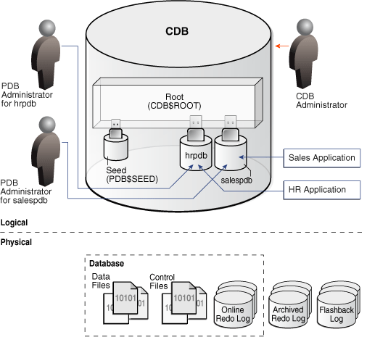



CDB

An Oracle Database installation that contains at least one [PDB](http://docs.oracle.com/database/121/CNCPT/glossary.htm" \l "GUID-D6932E25-775E-4FF1-BB08-F8999629093C). A PDB appears to an Oracle Net client as a traditional Oracle database. Every Oracle database is either a CDB or a [non-CDB](http://docs.oracle.com/database/121/CNCPT/glossary.htm" \l "GUID-B2710CAA-8F00-40B3-97AB-4521D2147EE8).

non-CDB

An Oracle database that is not a [multitenant container database (CDB)](http://docs.oracle.com/database/121/CNCPT/glossary.htm" \l "GUID-D4A51B19-8C03-4C98-81CE-15883B87E6E0). Before Oracle Database 12c, all databases were non-CDBs. Starting in Oracle Database 12c, every database must be either a CDB or a non-CDB.

PDB

In a [multitenant container database (CDB)](http://docs.oracle.com/database/121/CNCPT/glossary.htm" \l "GUID-D4A51B19-8C03-4C98-81CE-15883B87E6E0), a portable collection of schemas, schema objects, and nonschema objects that appears to an Oracle Net client as a traditional Oracle database ([non-CDB](http://docs.oracle.com/database/121/CNCPT/glossary.htm" \l "GUID-B2710CAA-8F00-40B3-97AB-4521D2147EE8)).

seed PDB

In a [multitenant container database (CDB)](http://docs.oracle.com/database/121/CNCPT/glossary.htm" \l "GUID-D4A51B19-8C03-4C98-81CE-15883B87E6E0), a default [pluggable database (PDB)](http://docs.oracle.com/database/121/CNCPT/glossary.htm" \l "GUID-15825EC2-B512-4FD1-A734-AE4DAB3B3AEC) that the system uses as a template for user-created PDBs. The name of seed is PDB$SEED.

common user

In a [multitenant container database (CDB)](http://docs.oracle.com/database/121/CNCPT/glossary.htm" \l "GUID-D4A51B19-8C03-4C98-81CE-15883B87E6E0), a database user that exists with the same identity in every existing and future [PDB](http://docs.oracle.com/database/121/CNCPT/glossary.htm" \l "GUID-D6932E25-775E-4FF1-BB08-F8999629093C).

container database

？？

container

？？

来自 <[http://docs.oracle.com/database/121/CNCPT/glossary.htm#CNCPT89131](http://docs.oracle.com/database/121/CNCPT/glossary.htm" \l "CNCPT89131)>